***Fantasy Hurling Game with Social Media Capabilities***

Project Proposal

*Project Skills*

*Michael James*

*B00019330*

*29/09/2014*

Submitted in part fulfilment for the degree of

**B.Sc. (Hons) Computing**

School of Informatics and Engineering,

Institute of Technology Blanchardstown,

Dublin, Ireland

Contents

Declaration 3

Project Specifics 4

Project Name: 4

Project Specifics 4

Project Supervisor: 4

Project Time Scale 4

Background 5

Why integrate Social Media? 6

Social Media Reach 6

Social Media in industry 7

The influence of social media on advertising Revenues 8

How we plan to integrate Social Media into our site 9

Main project Objectives 9

Success Criteria 9

Deliverables: 10

Management Deliverables: 10

Technical Deliverables: 10

Modelling 11

Potential risks 12

Risk Analysis: 12

Visibility Plan 13

Timescale 13

Resources Needed 13

Work Breakdown Structure (WBS) 14

Proposed Activity List 14

Phase 1 before Christmas 14

Phase 2 after Christmas 14

Gaant chart 15

Phase 1 15

Phase 2 Chart 16

Conclusion 17

Bibliography 18

# Declaration

I hereby certify that this material, which I now submit for assessment on the programme of study leading to the award of Degree of **Honours B.Sc. in Computer Science** in the Institute of Technology Blanchardstown, is entirely my own work except where otherwise stated, and has not been submitted for assessment for an academic purpose at this or any other academic institution other than in partial fulfilment of the requirements of that stated above.

# Project Specifics

## Project Name:

Fantasy Hurling Game with Social Media Capabilities

## Project Specifics

The objective of the project is to build a fantasy football hurling website, with an element of social media capabilities built in. The reasoning behind making this project is as follows. Anyone who plays fantasy football games knows that although they are quite interesting, a lot of the time is spent just logging in, checking your score, maybe making a change or two, and then logging out. The amount of time actually spent on the site is minimal, I feel this is a mistake in the design of these applications and games.

## Project Supervisor:

Luke Raeside

## Project Time Scale

29/09/2014 – 30/4/2015

# Background

U.S. businesses lose $200 million in productivity each football season because employees are managing their fantasy squads instead of working. Figures like this show how popular fantasy football is these days. Many hours are spent weekly by fans of all sports rolling the dice on a team’s new rising star and cursing their luck when he’s left out injured! The advertising potential as well as the potential for growth of these applications is why they are developed by companies, along with the love of the sport of course! [1]

*”Modern fantasy football can be traced back to the late Wilfred "Bill" Winkenbach, an Oakland area businessman and a limited partner in the Oakland Raiders. In a New York hotel room during a 1962 Raiders eastern cross-country trip, Winkenbach, along with Raiders Public Relations man Bill Tunnel and Tribune reporter Scotty Starling, developed a system of organization and a rulebook, which would eventually be the basis of modern fantasy football.”[2]*

*.*

# Why integrate Social Media?

### Social Media Reach

* 56% of people have a profile on a social media platform.
* 22% of people use a social media site very single day
* 47% of Facebook users say the site has an influence on their purchase behaviour through Advertisements on the site.
* 18-29 year olds have an 86% usage on Social Media[3]

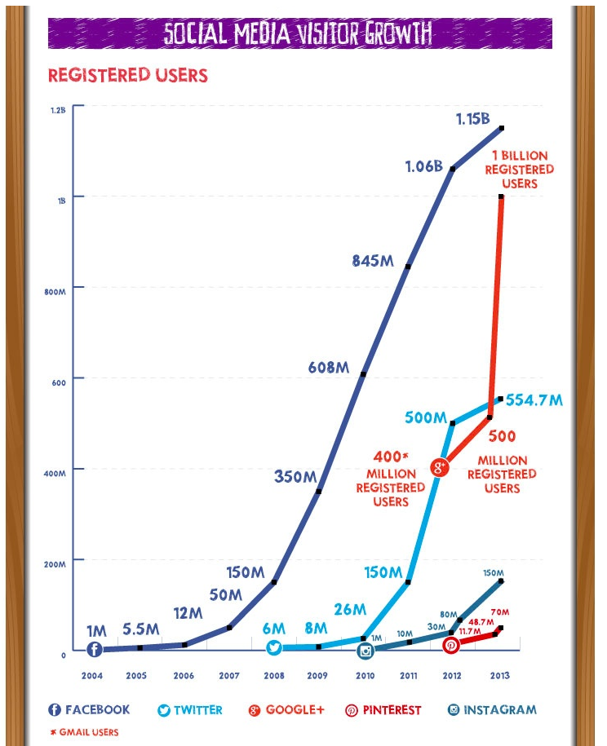

Figure 1: Social Media Growth Graph

# Social Media in industry

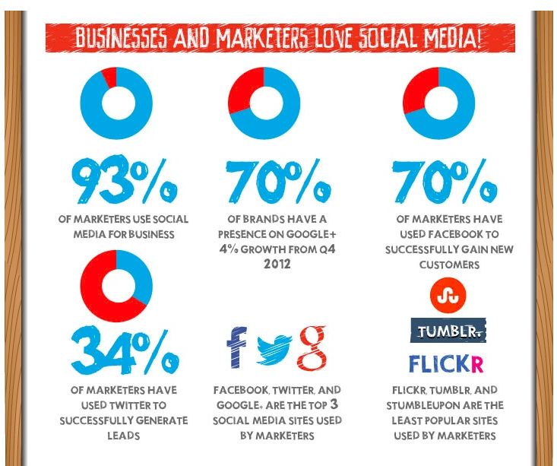

Figure 2: Pie charts showing the use of social media in business and advertising

As we can see social media is a major part of everyday life in modern times. To ignore it in any new website or application/game would be short-sighted. The advertising revenue that our fantasy hurling game could generate would be in the millions per year. Obviously the more time people spend on our site, the more revenue that could be gained, so we need to keep them on as long as we can! Our site will have plenty of uses who will spend time talking to other users via a messaging service and forum, users can also post trivia facts and ask questions as well as start discussions with other users. Each user has a profile which they can customise with their favourite teams colours. [4]

# The influence of social media on advertising Revenues

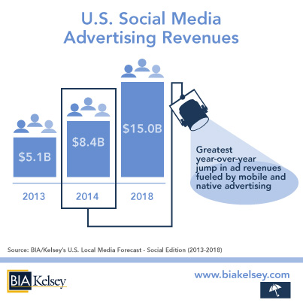

Figure 3: US advertising stats

* Social media advertising revenue growth stood at 31% last year.
* Total in monetary value was over 5 Billion Dollars
* Expected to be over 8 Billion Dollars for 2014

Business insider says it expects to see social media advertising revenues rocket in the next few years. It points to the amount of time people spend on these sites, and how the advertising can be targeted to a specific individual making it much more likely to be successful. For example a person regularly posting about football will be a lot more likely to be interested in buying something related to football, so ads can be tailored to an individual’s tastes increasing overall revenue.[5]

# How we plan to integrate Social Media into our site

We have a number of interesting ideas for our site to help it become more social and flexible.

* Each person has their own profile
* Each profile can have a main picture
* Can be customised by the user to display favourite teams colours
* Messages can be left for each user on their wall
* Forums can be used to talk about recent games or topics
* A GPS button can be clicked so that the user can see what people around his local area use the app and can talk to them
* An instant messaging service is available

### Main project Objectives

* Stable working website
* Play a fantasy game
* Social media aspects to it
* User can register
* Ads can be placed on the site
* Instant messaging service
* Forum service
* Scores update using RSS feed
* Player score updated automatically on login
* Admin can log in to do maintenance

### Success Criteria

* User should be able to register
* User should be able to select a team of 15 players
* User should be able to user instant messaging service to chat
* User can post on a forum
* Users points automatically updated each week
* User can chat with others near using a GPS system

# Deliverables:

### Management Deliverables:

Feasibility Study and Project plan: A feasibility study will be conducted so that a decision on the viability of the project can be made. This should contain an outline of the project along with the benefits, requirements and alternatives if any.

Analysis and design document: This document will contain all the requirements and functions that the Application should have. This will contain our UML diagrams which will plot how the user interacts with the software and what extra functions algorithms we might need.

Source code: We will use the Analysis and Design document to build the code for our software. This file should contain all code, images and installation files.

Testing Document: All tests performed on the software will contained in this. Testing will done in all stages of the application and be documented for further record.

### Technical Deliverables:

* A clear and easy way for a user to navigate through and complete the team selection
* User login to access an account or set up an account on first use.
* User should be able to change a player once a week
* Administrator login to change variables without interfering with ongoing game
* Database to store account details.
* Real time update of player scoring using RSS feeds
* Instant message style chat built in
* Forum messages used for discussion of games
* User able to join leagues and check overall standing

# Modelling

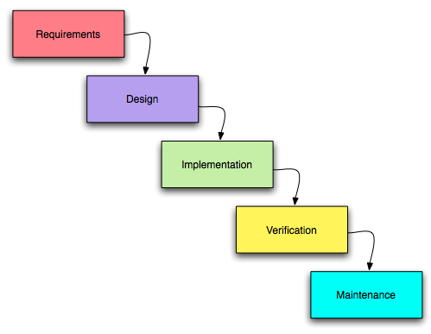

Figure: 4 Waterfall Model

We will be using the waterfall model in relation to the project. This model sets out a list of phases which each have their own tasks and requirements within them. Each phase much be finished before you set about going on to the next phase. It is considered an iterative process

#### Advantages of waterfall model:

* Simple and easy to understand and use.
* Easy to manage due to the rigidity of the model – each phase has specific deliverables and a review process.
* Phases are processed and completed one at a time.
* Works well for smaller projects where requirements are very well understood.

#### Disadvantages of waterfall model:

* Difficult to move back stages
* No working software is produced until late during the life cycle.
* Not a good model for complex and object-oriented projects.
* Poor model for long and ongoing projects.

# Potential risks

# Risk Analysis:

#### Requirements disagreements

There is already a fantasy GAA official game, although there is no hurling they could decide at any time to develop one, and with official sponsorship we would struggle to compete. There is also the risk that the reason one has not been developed is because nobody would play it! I do not believe this to be the case however I feel it is an over-sight on behalf of the makers of the GAA football fantasy football site to miss out on this opportunity.

#### Cross Platform Issues:

The app should be available on many platforms, which in itself creates some problems. We have decided of course to develop the app in the Java programming language as it gives very good flexibility in this regard.

#### Budget Constraints:

*The client budget of course is vital to our project. We must find a balance between giving the client the polished and usable app required while staying within the budget the client has laid out, there has been communications to us from the client to state that a 15% top up on the budget is there if needed, however we feel we ought to try keep to the initial budget for both the clients sake and the integrity of our company.*

#### Human Resources:

We have only 3 team members working on the project which raises some concerns in itself. Time will be an issue with such a small team, however good design and analysis of the project will allow us come up with a very specific set of targets and guidelines for each team member to meet to allow the product be finished on time, which I feel is very important.

#### Licencing Issues

Our clients’ budget does not allow for the procuring of expensive licences for logos or jerseys to be used in our product. However this I feel will be a minor issue once we steer clear of using these while still creating a visually appealing application, time will be spent in the week 7 phase to come up with a visual design for the product which is appealing to client and customer alike.

# Visibility Plan

The team will consult the client on a weekly basis and conduct any necessary further

Communication via an instant messaging app such as Skype which will keep all parties involved in real time and make sure any changes or adaptations are relayed to all parties very quickly and efficiently. Our team will draw up repots every 3 days which will be forwarded to the client which will keep all parties up to date on the progress that has been made so far.

Our group will meet once a week on Mondays between 11 and 1 to discuss and concerns or simply relay information to the other group members about their experiences so far in the tasks they have been assigned.

### Timescale

The timescale to develop this application is set at 8 months total from design to roll out. The first 3 months will be used to draw up the overall design and scope documents including UML diagrams and some statistical analysis. The final 5 months will be used to develop the application through the actual coding, and test the end result very thoroughly to make sure it meets industry standards.

### Resources Needed

* 3 members of staff
* Budget of 5 thousand euros
* Approximately 15 man hours per week during design phase , during the second implementation phase, around 35
* 3 laptops
* Microsoft Office
* Windows 7 on all laptops
* USB Web Server to test web pages
* We will work from home, meeting up regularly to discuss new ideas and collaborate on certain aspects of the project.

# Work Breakdown Structure (WBS)

## Proposed Activity List

### Phase 1 before Christmas

1 List essential things needed

2 Check up on technologies we could use

3 Check copyrights

4 Check prices on any hardware we may need

5 Decide on whether or not to go ahead with project

6 Select a design method

7 Create detailed Spec

8 Plan staff workload and duty

9 Plan timescale

10 Choose technologies

11 Decide on site design

12 Choose a project Supervisor

13 Decide on a final budget

### Phase 2 after Christmas

14 Write Java code

15 Write HTML code for site

16 Tie together with Java enterprise Server

17 Assess Diary Documentation of each staff member

18 Select Testing methods

19 Test project

20 Roll out project

# Gaant chart

As this project is very much broken into two parts, one before Christmas and one after I have done out two separate Gaant charts to keep things as neat and easy to read as possible!

Week 1 starts October 1st and week 10 ends 14th December

Week 14 starts January 14th and week 34 ends in April when the final project is handed in

## Phase 1

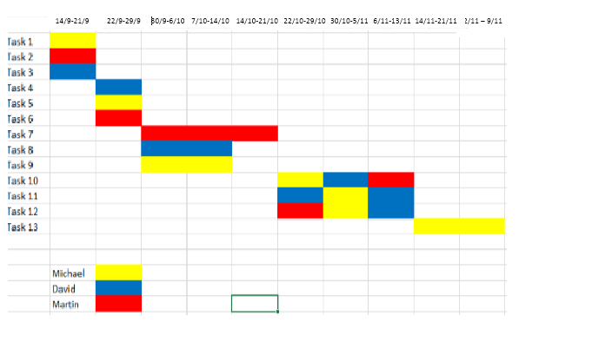

## Phase 2 Chart

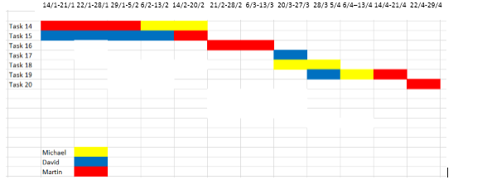

# Conclusion

The project is ready to begin, some changes may occur throughout the process but in all aspects of planning I feel it is ready to go.

# Bibliography

[1]By Erik Barmack and Max Handelman (2006) Retrieved 5/10/2014

<http://books.simonandschuster.com/Why-Fantasy-Football-Matters/Erik-Barmack/9781416909965>

[2]By Matt Hunt (2013) Retrieved 5/10/2014

<http://entertainment.howstuffworks.com/fantasy-football2.htm>

[3]By Jay Baer (2012) Retrieved 5/10/2014

<http://www.convinceandconvert.com/social-media-research/11-shocking-new-social-media-statistics-in-america/>

[4]By BIA Kelsey (Retrieved 5/10/2014)

<http://www.biakelsey.com/Company/Press-Releases/140515-U.S.-Social-Media-Advertising-Revenues-to-Reach-$15B-by-2018.asp>

By Business Insider (2013) Retrieved 5/10/2014

[5]<http://www.businessinsider.com/social-media-advertising-set-to-explode-2013-7>